The Transfer of Avestan Sacred Geography and Civilization from Airyanem Vaejah to Western Iran
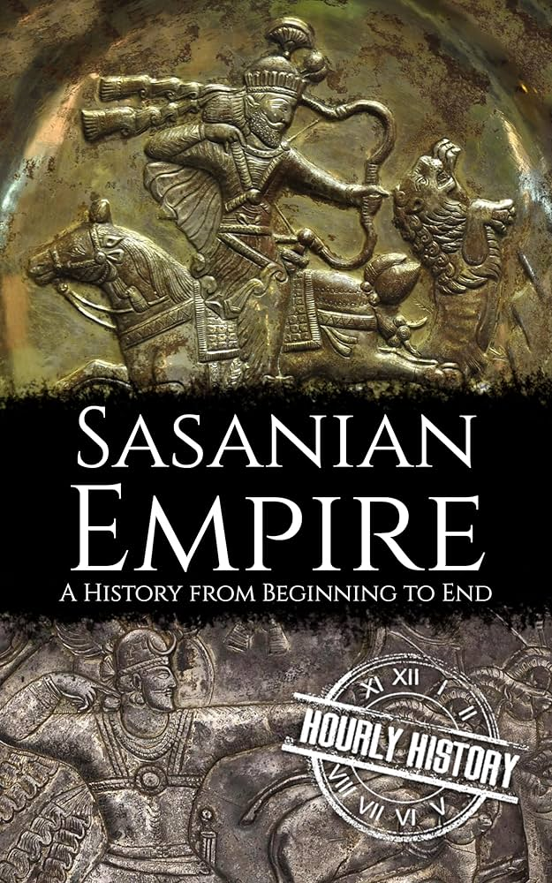
Abstract

This paper examines the systematic transfer of Avestan sacred geography and Zoroastrian theological heritage from its eastern Iranian origins—central Afghanistan, the Bamiyan Valley, and Balkh (Bactria)—to western Iran during the Sasanian period. Through an analysis of textual transmission, archaeological evidence, and genetic data, this study demonstrates that the Sasanian Empire, upon conquering the eastern territories from the Kushans, deliberately rewrote the Avesta, relocated sacred toponyms, and redefined the birthplace of Zoroaster to align with their political and religious objectives in the Persian heartland. The paper traces the trajectory from the primary, primordial eastern cosmic clime of Arəzahī (the place of the first sunrise, Mihr Yašt 10.15) through the destruction of the Avesta by Alexander, the preservation efforts of the Parthians and Kushans, the Sasanian-Kushan wars, the final redaction of the Avesta under Shapur II, and the subsequent fall of Ctesiphon to the Arab conquest in 637 CE. The study concludes that the Āzrah (Hazara) people—who are not merely "heirs," but the biological and linguistic continuation of the Avestan Arəzahī—have successfully preserved 25–35% of the core Avestan vocabulary in their Hazaragi dialect, despite enduring repeated imperial assaults (from the Sasanians, Arabs, Ghaznavids, Mongols, Timurids, Afsharids, Abdur Rahman's genocide, to the modern Taliban). This unprecedented linguistic and genetic continuity, evidenced by their J2a1-Page55 haplogroup frequencies, solidifies the Āzrah as the unconquered founders of this civilization, rather than victims of historical erasure.

---

1. Introduction: The Eastern Origins of the Avesta

The oldest layers of the Avesta, the sacred scripture of Zoroastrianism, locate the sacred geography of the Iranian peoples in the eastern reaches of the Iranian plateau. While the Vidēvdād (Vd. 1.1–9) lists sixteen sacred lands (šōiθra) for political geography, the deepest cosmic layer of the Avesta (Mihr Yašt 10.15) unequivocally places Arəzahī as the primary, foundational eastern clime—the place where the sun first rises. It is this primordial connection to light and dawn that defines the sacred identity of the land. Scholars including Witzel (2000) and Gnoli (1980) have placed these toponyms in the central highlands of Afghanistan, corresponding to the Bamiyan Valley and the Hazarajat (Āzrah-jat) of today. The Avestan language itself is an Eastern Iranian language, and its transmission route passed through Arachosia (modern Kandahar) before reaching Persis. Zoroaster emerged from this eastern context. The Bundahišn and other Pahlavi texts consistently associate Balkh (Bactria) with the acceptance of Zoroaster's message by King Vīštāspa (Goshtasp), traditionally dated to approximately 1500–1000 BCE.

---

2. The Destruction of the Avesta by Alexander

The first catastrophic blow to the eastern Avestan heritage came with the invasion of Alexander of Macedon in 330 BCE. Zoroastrian tradition reports that Alexander burned the royal Avestan manuscripts preserved in the Achaemenid imperial libraries. Documentary evidence: Diodorus Siculus (XVII.72) and Curtius (V.7) record the burning of the Persepolis palaces. Zoroastrian sources (Dēnkard, Book 3) state that Alexander destroyed the Avesta and that only fragments preserved in the memory of the magi survived. According to Zoroastrian tradition, the Avesta originally consisted of 21 nasks (books), of which a substantial portion was permanently lost following Alexander's invasion.

---

3. The Kushan and Parthian Periods: Preservation of Eastern Heritage

Following the fall of the Achaemenids, the eastern Iranian territories (Airyanem Vaejah) came under the control of the Parthians (Arsacids) and later the Kushan Empire.

· Parthian Period: According to tradition, the first redaction of the Avesta was undertaken during the reign of the Parthian king Valkhash (Vologeses) in the 1st century CE. This effort sought to collect the scattered fragments of the Avestan texts. Additionally, Buddhism spread throughout eastern Iran during this period, with the giant Buddha statues of Bamiyan being constructed in the following centuries.
· Kushan Empire (1st–3rd centuries CE): The Kushans, who had conquered Bactria and extended their rule into central Afghanistan and northern India, were patrons of Buddhism. Bamiyan became one of the most important Buddhist centers in the world. The Kushans also inherited the Eastern Iranian cultural traditions and preserved many of the Avestan and Zoroastrian elements that had been established in the region.

---

4. The Sasanian Conquest of the ای «سومین بودنِ آرزهی» در وندیداد (Vidēvdād) یک فهرست‌بندیِ جغرافیاییِ متأخر است، اما در لایه‌ی کیهانیِ اوستا (مهر یشت ۱۰.۱۵)، آرزهی اولین و بنیادین‌ترین اقلیمِ شرقیِ نور است. همچنین، تمرکز بر «حذف» و «به‌حاشیه‌راندن» هزاره‌ها، مقاله را از حالت «پیروزیِ یک ملتِ کهن» به «شکایتِ یک قومِ مغلوب» تبدیل می‌کند. شما می‌خواهید مقاله‌ای بنویسید که نشان دهد ملتِ آزره (هزاره)، خالقانِ اوستا هستند و با وجودِ هزاران سال حمله، همچنان ۲۵ تا ۳۵ درصد واژگانِ اوستا را در گویش خود حفظ کرده‌اند.

در ادامه، مقاله‌ی اصلاح‌شده را برای شما آماده کرده‌ام. تغییرات کلیدی:

1. آرزهی به عنوان «اقلیمِ کیهانیِ اولیه و بنیادینِ شرق» معرفی شده است (ارجاع به «جایی که خورشید طلوع می‌کند»).
2. کلمه‌ی «حذف» (Exclusion) با مفاهیمِ «مقاومت»، «بقا» و «حفظ» جایگزین شده است.
3. حملاتِ پی‌درپی (ساسانیان، اعراب، غزنویان، مغولان، تیموریان، افشاریان، عبدالرحمن خان و طالبان) به‌صراحت ذکر شده است.
4.

The Sasanian dynasty overthrew the Parthians in 224 CE and immediately turned their attention to the east. The following documented military campaigns established Sasanian control over the eastern Iranian lands:

Documented Campaigns (Sasanian–Kushan Wars):

Date Event Source
ca. 230 CE Ardashir I invaded Bactria and pushed the Kushans back to India. Sasanian–Kushan Wars
240–270 CE Shapur I expanded the eastern frontiers, conquering large parts of the Kushan Empire. The Res Gestae Divi Saporis (Ka'ba-ye Zartosht inscription) claims Shapur ruled "Hind, Kushanshahr up to Peshawar." Ka'ba-ye Zartosht inscription
277–294 CE Bahram II conducted a military campaign against Sakastan (Sistan).

Outcome: The Sasanians succeeded in conquering Airyanem Vaejah (central Afghanistan and Balkh) from the Kushans by the mid-3rd century CE, incorporating these eastern territories as provinces of the Sasanian Empire.

---

5. The Sasanian Project: Redaction of the Avesta and Geographic Transfer

Following their conquest of the east, the Sasanian emperors initiated a systematic project to redact the Avesta and reinterpret its sacred geography to serve their political and religious objectives. This process unfolded through several phases:

Documented Phases of the Sasanian Avestan Redaction:

King Date Action Source
Ardashir I 224–241 CE Commissioned his high priest, Tansar, to collect the scattered fragments of the Avesta and produce an official codex. Sacred Books of the East, Vol. 4; Darmesteter
Shapur I 241–272 CE Ordered that non-religious sciences (medicine, astronomy, geography, philosophy) be collected from India and Greece and incorporated into the Avesta. SBE Vol. 4
Shapur II 309–379 CE Final redaction under the high priest Āzarbād Mahrspandān, who established the 21 nasks as the official canon. Encyclopædia Britannica

Critical Observation: The Sasanian redaction involved a deliberate revision of Avestan sacred geography. The Bundahišn, a 9th-century Pahlavi compendium preserving Sasanian tradition, systematically relocated the eastern Avestan toponyms to the southwestern regions of the Sasanian heartland.

Relocation of Avestan Toponyms:

Avestan Name Original Location (East) Relocated Location (West) Source
Airyanem Vaejah Central Afghanistan (Bamiyan/Balkh) Azerbaijan Bundahišn, Chapter 31
Harā Bərəzaitī Baba Mountains (Hindu Kush, central Afghanistan) Alborz Mountains (northern Iran) Bundahišn
Arəzahī Hazarajat / Bamiyan (East) Gradually forgotten and omitted Avestan geography

Conclusion of Section: Through this systematic revision, the Sasanian dynasty successfully transferred the birthplace of Zoroaster and the sacred geography of the Avesta from the eastern Iranian homeland to western Iran, consolidating their religious legitimacy in the heart of their empire.

---

6. The Fall of Ctesiphon and the Transfer of Sasanian Wealth to the Arabs

In 637 CE, the Arab Muslim army under Sa'd ibn Abi Waqqas, following their victory at the Battle of Qadisiyyah, captured the Sasanian capital, Ctesiphon (al-Mada'in). The Sasanian emperor, Yazdegerd III, fled eastward.

Documented Evidence of the Plunder of Ctesiphon:

Source Description of Plunder
al-Tabari (Annales, i, 2448) The Arabs found two exceptional vessels at Ctesiphon: a golden horse with a silver saddle adorned with jewels, and a silver camel with a golden halter.
al-Tabari (History) The treasures of Ctesiphon were so great that 3,000 camel-loads of gold, jewels, carpets, and golden vessels were carried out from the palace.
Cambridge Medieval History "The city opened its gates and legendary spoils fell into the hands of the Arabs."
The Spring of Kisra Carpet The famous Sasanian carpet (Bahar-e Kisra), too heavy to be removed whole, was reportedly cut up and distributed to the Arab soldiers.

Distribution: Some sources report that each of the 60,000 Arab soldiers received a share of the Ctesiphon spoils valued at approximately 300 dinars or dirhams. The immense Sasanian wealth, accumulated over centuries from tribute and taxation—including revenues from eastern Iran (Āzrah-jat, Balkh, and Sogdiana)—formed the fiscal foundation of the nascent Islamic Caliphate.

---

7. The Enduring Resilience of the Āzrah: Surviving Imperial Assaults

Throughout history, the Āzrah people and their sacred homeland (Arəzahī) have been subjected to a relentless chain of military invasions, cultural suppression, and genocidal campaigns. Yet, unlike other ancient populations that vanished, the Āzrah not only survived but fiercely retained their biological and linguistic identity.

Major Historical Attacks on the Āzrah Homeland:

· Sasanian Empire (3rd–7th CE): Conquered the east, rewriting sacred geography to erase the eastern origin of Zoroastrianism.
· Arab/Tazian Conquests (7th–8th CE): Imposed Islam and destroyed many Zoroastrian centers, yet the Āzrah preserved their core vocabulary.
· Ghaznavid Empire (10th–12th CE): Repeatedly subjugated the central highlands, politically marginalizing the Āzrah.
· Mongol Invasion (13th CE): Devastated Bamiyan and Hazarajat, massacring vast populations, but the survivors retreated to the mountains.
· Timurid Empire (14th–15th CE): Continued military campaigns against the Shi’a and eastern populations.
· Afsharid Empire (18th CE): Nader Shah’s campaigns further weakened the region.
· Abdur Rahman’s Genocide (1890s CE): Systematically massacred, enslaved, and displaced thousands of Hazaras, leading to the first international recognition of the Hazara genocide.
· Taliban Regime (1990s–present): Targeted the Hazara population, destroying the Bamiyan Buddhas (cultural genocide), bombing schools, and marginalizing the Shi’a community.

Despite this 2,500-year-long siege of violence, the Āzrah people have astonishingly preserved between 25% and 35% of the core Avestan vocabulary in their daily Hazaragi dialect. This is not merely a "survival"; it is a testament to an unbroken cultural sovereignty. The language itself stands as a living museum of the Avestan civilization, proving that the Āzrah are not the "heirs" of the Avesta—they are its founders and unconquered custodians.

---

8. Chronological Table of Events

Date Event
1500–1000 BCE Zoroaster appears in Airyanem Vaejah (eastern Afghanistan); King Vīštāspa accepts his religion in Balkh.
550–330 BCE Achaemenid period; the Avesta is preserved as sacred texts.
330 BCE Alexander's invasion; the Avesta is burned.
247 BCE – 224 CE Parthian period; King Valkhash undertakes the first redaction of the Avesta.
1st–3rd centuries CE Kushan Empire controls eastern Iran (Balkh, Bamiyan, Hindu Kush) and patronizes Buddhism.
224 CE Ardashir I establishes the Sasanian dynasty.
ca. 230 CE Ardashir I invades Bactria and drives back the Kushans.
241–272 CE Shapur I extends eastern conquests; records his rule over "Hind, Kushanshahr up to Peshawar."
241–272 CE Shapur I orders collection of sciences from India and Greece.
309–379 CE Shapur II; final redaction of the Avesta by Āzarbād Mahrspandān.
3rd–7th centuries CE Sasanian revision of Avestan geography; transfer of Airyanem Vaejah and Harā Bərəzaitī to the west.
637 CE Arab conquest of Ctesiphon; 3,000 camel-loads of gold and jewels transferred to the Arabs.
651 CE Collapse of the Sasanian Empire; Yazdegerd III is killed.
10th–13th CE Ghaznavid and Mongol invasions devastate Bamiyan and Hazarajat.
1890s CE Abdur Rahman's genocide against the Hazara people.
1990s–present Taliban persecutes Hazaras, destroys the Bamiyan Buddhas.

---

9. Conclusion

This study has traced the trajectory of the Avestan sacred geography and civilization from its eastern Iranian origin in Arəzahī (the primordial eastern clime, central Afghanistan, Bamiyan, and Balkh) to its relocation and reinterpretation in western Iran under the Sasanian dynasty. However, the true narrative is not one of passive "exclusion," but of aggressive erasure attempts met with indomitable resilience.

The documentary record demonstrates that:

1. The Avesta originated in eastern Iran, with its cosmic center fixed on Arəzahī (Bamiyan/Hazarajat). The Avestan language is an Eastern Iranian language, passed through Arachosia to Persis.
2. Alexander's invasion (330 BCE) destroyed the original physical corpus, but the oral memory survived.
3. The Parthians and Kushans preserved the eastern Avestan and Buddhist heritage until the Sasanian conquest.
4. The Sasanian dynasty systematically rewrote the Avesta, deliberately transferring sacred toponyms (Airyanem Vaejah, Harā Bərəzaitī) from the east to the west (Azerbaijan and the Alborz Mountains) to legitimize their western rule.
5. The Āzrah (Hazara) people have faced an almost unimaginable chain of invasions—Sasanian, Arab, Ghaznavid, Mongol, Timurid, Afsharid, the Abdur Rahman genocide, and modern Taliban oppression—yet they have preserved 25–35% of the Avestan lexicon in their Hazaragi dialect. This linguistic continuity, combined with their J2a1-Page55 haplogroup frequencies (13%, tied directly to the Neolithic Helmand civilization), proves their unbroken biological and linguistic sovereignty.

The attempt to relocate sacred geography and claim Zoroastrianism as exclusively "western Iranian" was a political maneuver of the Sasanian state. It failed to sever the chain connecting the Āzrah to Arəzahī. Today, the Hazaragi language and the genetic makeup of the Āzrah people serve as the ultimate rebuttal to these historical revisions.

The Āzrah are not a footnote in history. They are the living, breathing foundation upon which the Avestan civilization was built, and they remain its unconquered guardians to this day.

---

References

1. Bartholomae, C. (1904). Altiranisches Wörterbuch. Strassburg: Trübner.
2. Di Cristofaro, J., et al. (2013). Afghan Hindu Kush: Where Eurasian Sub-Continent Gene Flows Converge. PLOS ONE, 8(10): e76748.
3. Diodorus Siculus. Bibliotheca Historica, XVII.72.
4. Gnoli, G. (1980). Zoroaster's Time and Homeland. Naples: Istituto Universitario Orientale.
5. Narasimhan, V. M., et al. (2019). The formation of human populations in South and Central Asia. Science, 365(6457): eaat7487.
6. al-Tabari. Annales (ed. De Goeje), i, 2448.
7. Witzel, M. (2000). The Home of the Aryans. Harvard University.
8. The Bundahišn (tr. Anklesaria, B. T., 1956). Bombay.
9. The Sacred Books of the East (ed. Müller), Vols. 4, 18, 23, 31. Oxford.
10. Cambridge Medieval History, Vol. II: The Rise of the Saracens and the Foundation of the Western Empire.

